TEMPLATE
Lake Vegetation Management Plan
- short form -
Minnesota Department of Natural Resources to authorize a variance(s) to allow control of
invasive aquatic plants

Draft_ _ or Final without signatures __ or Final with signatures _ X _. Date: 14 February 2013.

If approved, date of last signature: ________________

Lake: ___Lake Susan____________ DOW Number: ____10.001300______

Nearest Town: ____Chanhassen________ County: _____Carver___________

Classification of the lake: _____General Development_________________

Section 1: Description of the lake and its water quality

Surface acres. Total: 88 Littoral (< 15 feet deep) : 75

Water quality:

Average Total Phosphorus: 175 ppb Number of observations: 42

Date: 2002-2011

Average Chlorophyll a: 48 ppb Number of observations: 69

Date: 2002-2011

Average Secchi depth: 3.3 ft Number of observations: 49

Date: 2002-2011

Section 2: Aquatic plant community

Aquatic plant surveys for Lake Susan were completed in 2009, 2010, 2011 and 2012 by University of Minnesota graduate students and followed the point intercept methodology (Madsen 1999). Aquatic plants were surveyed at 146 points up to a depth of 16.7ft and 122 points within the littoral zone (≤ 15ft). The maximum depth for the 95th percentile of submersed plant occurrence was 10.5 feet in the 2012 survey. Results in Table 1 are for peak curly-leaf pondweed growth in spring (May or June); results of all the surveys are given in Appendix 1. Maps with curly distribution are given in Appendix 2.

Table 1. Percent frequency of plants observed in the littoral zone of Lake Susan during aquatic plant surveys in the peak curly-leaf season of May or June 2009, 2010, 2011 and 2012.

 |  | Submersed |  |  |  |  |  |  |  | Float-leaf |  |  | Free-Float
 |  | Dicots |  | Monocots
 |  | Native | Non-Native | Non-Native | Native
Year | Month | Ceratophyllum demersum | Myriophyllum spicatum | Potamogeton crispus | Elodea canadensis | Potamogeton pusillus | Najas flexilis | Stuckenia pectinata | Zannichellia palustris | Nymphaea odorata | Nelumbo lutea | Nuphar variegate | Lemna minor
2009 | Jun | 43 | 35 | 17 |  | 15 |  | 1 | 6 | 10 |  | 5 | 3
2010 | Jun | 37 | 21 | 28 | 4 | 33 | 8 | 6 |  | 8 | 8 | 9
2011 | Jun | 53 | 13 | 42 | 27 | 35 | 5 | 7 |  | 5 | 5 | 6 | 3
2012 | May | 28 | 17 | 40 | 14 | 20 |  | 2 |  | 2 | 7 | 8

Section 2a: Prior management that may be relevant to future management of aquatic plants in the lake

Since carp removal in 2009, submersed aquatic plants have been increasing. Water clarity increased in spring after carp removal though it remains low in July and August (Appendix 3). Eurasian watermilfoil appears to be controlled by the milfoil weevil (average Aug frequency < 10%) and is currently not a problem. Curlyeaf pondweed frequency of occurrence and turion densities are increasing (Appendix 4). Frequency of curly-leaf pondweed has increased from 17% in 2009 to 40% in 2012 surveys. Curly-leaf pondweed matted surface area increased from approximately 9.8 acres (13%) of the littoral zone in 2011 to 13.2 acres (18%) in 2012. Additionally, turion abundance within the sediments has increased in each subsequent year.

Section 3: Public participation process used in development of the plan

There are approximately 19 priviate (plus the city of Chanhassen and the Lake Susan Appartment Homes) shoreline owners surrounding Lake Susan.

Public meetings: A public meeting to address plant management strategies with lake shore homeowners took place at the Chanhassen American Legion on 11 December 2012. Representitives from the University of Minnesota, the Minnesota Department of Natural Resources and Riley Purgatory Bluff Creek Watershed District (hearafter Disctrict) were in attendance at the public meeting. Residents were notified about the meeting via email on 20 November 2012 and 7residents were in attendance. Trends in water quality and plant abundance and community composition after carp removal were discussed along with increases in curlyleaf pondweed occurrence, biomass and turion abundance. Options to reduce nuisance plants and inhibit curlyleaf pondweed expansion while enhaning the native plant community were discussed. It was agreed that coordinated, lake-wide, low dose, herbicide treatments to control curlyleaf pondweed would be the most effective approach. The Watershed District agreed to coordinate lakeshore owner consent and herbicide treatments, assist with costs and apply for grants from the DNR. Minutes of the meeting were circulated to lakeshore owners on 17 December 2012 and the District followed up to obtain consent or opt-out from all shoreowners with a letter on 25 January 2013. All shoreowners agreed to the treatments.

Provisions for opt out – all lake residents were invited to the meeting and sent a letter detailing plans. Residents could opt out by checking the opt out box on the letter. A final letter providing one last option to opt out of treatment will be sent to all residents by 20 March 2013.

Section 4: Problems to be addressed

Problem A: Curly-leaf pondweed (CLP) interferes with use of the lake.

Problem B: Low water clarity and low distribution and abundance of native aquatic plants.

Problem C: CLP turion abundance has increased in each survey period from 2010 through 2012.

Problem D: There is concern that Eurasian watermilfoil could increase, particularly if milfoil weevil populations decrease.

Problem E: Overly aggressive control of invasive aquatic plants might further limit native plants and water clarity.

Section 5: Goals for management of aquatic plants

Goal A: Control curly-leaf pondweed to reduce interference with use of the lake.
Objective A-1: Measurable outcome – Reduce delineated acres of curly-leaf pondweed in spring
Objective A-2: Measurable outcome – Reduce delineated acres of surface-matted curly-leaf pondweed

Goal B: Control curly-leaf pondweed in a way to protect native aquatic plants.
Objective B-1: Measurable outcome – The frequencies of native plants shall be maintained or allowed to increase as determined by results of surveys in mid-summer of each year after treatment.

Goal C: Control curly-leaf pondweed in a way to further research or evaluate invasive aquatic plant control.
Objective C-1: Evaluate whether curly-leaf pondweed treatment can effectively maintain reduced frequency and abundance in Lake Susan for multiple years after lake-wide treatment (results of vegetation surveys).
Objective C-2: Evaluate whether curly-leaf pondweed treatments can maintain or reduce abundance of curly-leaf pondweed turions in lake sediments for multiple years after lake-wide treatment according to results of fall sediment turion surveys.

Section 6: Proposed actions to achieve goals and a map showing the location of the proposed actions

A. Provide a brief description of the pest management options considered besides the use of pesticides, keeping in mind the impact to water quality, impact to non-target organisms, feasibility, and cost effectiveness. Also list any relevant previous Pest Management Measures.

- Target Pest: Curly-leaf pondweed

- No Action: Curly-leaf pondweed has increased each year since removal of common carp in 2009 and the beginning of the University of Minnesota surveys. It is anticipated that curly-leaf will continue to increase if no action is taken.
- Prevention: The Minnesota Department of Natural Resources (MN DNR) has an Aquatic Invasive Species (AIS) program to stop the spread of invasive species. Infested waters are designated and posted with signage. Stop Aquatic Hitch-hiker signs are posted throughout Minnesota. Enforcement of AIS laws is taking place. Watercraft inspectors are hired by the DNR and often positioned at the public launch of Lake Susan to educate and assist boaters with boat cleaning procedures.

- Mechanical/Physical Methods: Mechanical harvesting methods and weed rollers have been used on an individual basis by landowners who chose to do so. No commercial harvesting is known to have taken place at this time.

- Cultural Methods: These are manipulations of the habitat to increase pest mortality by making the habitat less suitable to the pest. For example one might dredge a lake to make it too deep for the pest, an invasive aquatic plant, to obtain enough light to survive. Generally, such approaches are infeasible due to high cost and potential to reduce abundance of desirable of native plants.

- Biological Control Agents: No effective agents for curly-leaf pondweed have been identified, nor are any possible agents being evaluated, as far as is known at present.

B. Proposed actions: Selective control by application of herbicide to areas with curly-leaf pondweed in up to 15 acres, which is 20 % of the littoral zone (water depth up to 15 feet).

Approach: early-season application of endothall herbicide (0.75 to 1.0 mg/L localized target concentration) to areas with curly-leaf pondweed (Fig. 1).

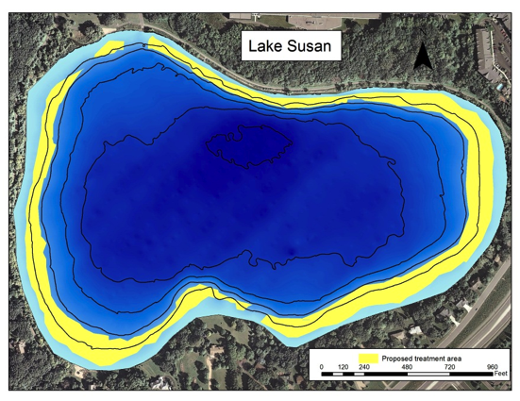
Figure 1. Map of Lake Susan showing the location of the proposed actions in yellow.

Section 7: Conditions of APM permits to be issued as part of this plan, including variances

A. Variance: Application of herbicide to 15 acres, which is greater than 15% of the littoral area and a variance from the provision in M.R. 6280.0450, Subp. 4, A.

Justification: A variance is justified because control of curly-leaf pondweed in more than 15% of the littoral area in combination with removal of common carp may have potential to increase or protect native aquatic plants. Monitoring of the effects of these treatments will further research and evaluation of the effects of aquatic plant control on curlyleaf and the response of native plant communities.

B. Waiver: Waiver of requirement for signatures (M.S. 103G.615) We have obtained signatures from 100% of residents – no waiver needed.

C. Condition: Any application for a permit to allow subsequent chemical treatments to control native submersed plants within the same season shall be subject to inspection and shall be permitted no more than 50 shoreline feet, or half their lake frontage, whichever is less, by 50 feet lakeward plus a 15 foot channel to open water. Offshore treatment of native submersed plants shall not be permitted. Should native submersed plants rebound to a large extent causing recreational nuisances, this limitation will be revisited. Permits to allow treatment to control native submersed plants shall require a separate permit and shall require annual signatures of approval from all landowners whose shorelines will be treated.

Section 8: Required monitoring:
 | What? | By whom?
a | Delineation of curly-leaf pondweed or other invasive aquatic plants in spring | University of Minnesota researchers
b | A point-Intercept survey in mid-summer when native submersed plants are at or near maximum levels of abundance | University of Minnesota researchers
c | Observations of Secchi depth at biweekly intervals, i.e., twice per month, or more frequently, from 1 May through 30 September. | University of Minnesota researchers, Riley Purgatory Bluff Creek Watershed District
d. | Collection of water samples for analysis of concentration of phosphorus and chlorophyll a | University of Minnesota, Riley Purgatory Bluff Creek Watershed District

A report outlining the results of monitoring the previous summer will be provided to the DNR by 15 February each year.

Section 9: LVMP Signatures

This Lake Vegetation Management Plan is in effect for five (5) [2013-2017] years from date of the last approval by the DNR.

This LVMP was prepared and submitted by:

Name: Claire Bleser

Title:
Date: District Administrator , Feb 14, 2013

Signatures of approval:

Name:_________________________  Title: _________________________________  (Division of Ecological & Water Resources) | ______________________________________  Date
Name:_________________________  Title: _________________________________  (Division of Fish & Wildlife) | ______________________________________  Date

I affirm that I am an authorized representative of the Riley-Purgatory-Bluff Creek Watershed District and acknowledge the University of Minnesota’s participation in the development and implementation of this lake vegetation management plan.
Name: Claire Bleser  Title: District Administrator | 02/13/2013  Date
Either party may terminate participation in this plan at any time, with or without cause, upon 30 days’ written notice to the other party.

Appendix 1. Results of aquatic vegetation surveys within the littoral zone of Lake Susan in 2009, 2010, 2011 and 2012. (percent frequency of occurrence).

 |  | Submersed |  |  |  |  |  |  |  | Float-leaf |  |  | Free-Float
 |  | Dicots |  | Monocots
 |  | Native | Non-Native | Non-Native | Native
Year | Month | Ceratophyllum demersum | Myriophyllum spicatum | Potamogeton crispus | Elodea canadensis | Potamogeton pusillus | Najas flexilis | Stuckenia pectinata | Zannichellia palustris | Nymphaea odorata | Nelumbo lutea | Nuphar variegate | Lemna minor
2009 | Jun | 43 | 35 | 17 |  | 15 |  | 1 | 6 | 10 |  | 5 | 3
 | Aug | 37 | 32 | 6 | 2 | 17 |  | 3 | 1 | 8 | 7 | 5
2010 | Jun | 37 | 21 | 28 | 4 | 33 | 8 | 6 |  | 8 | 7 | 9
 | Aug | 30 | 4 | 2 | 2 | 18 | 4 | 10 |  | 4 | 4 | 7
 | Sep | 32 | 8 | 6 | 2 | 6 | 6 | 5 |  | 6 | 6 | 4
2011 | May | 43 | 10 | 29 | 11 | 14 |  | 10 |  |  | 7 | 1
 | Jun | 53 | 13 | 42 | 27 | 35 | 5 | 7 |  | 5 | 5 | 6 | 3
 | Aug | 39 | 10 | 7 | 23 | 31 | 1 | 6 |  | 8 | 11 | 5 | 5
2012 | May | 28 | 17 | 40 | 14 | 20 |  | 2 |  | 2 | 7 | 8
 | Jun | 34 | 10 | 23 | 19 | 22 |  | 8 |  | 6 | 10 | 5
 | Aug | 23 | 1 | 2 | 11 | 7 |  | 1 |  | 6 | 11 | 7 | 1

Appendix 2. Curly-leaf pondweed occurrence and relative density (rake rating of 0 to 5; 0 = no plants, Low = 1-2, Med = 3-4 and High = 5 (full rake) and delineated areas of contiguous surface matting in Lake Susan in 2010-2012.
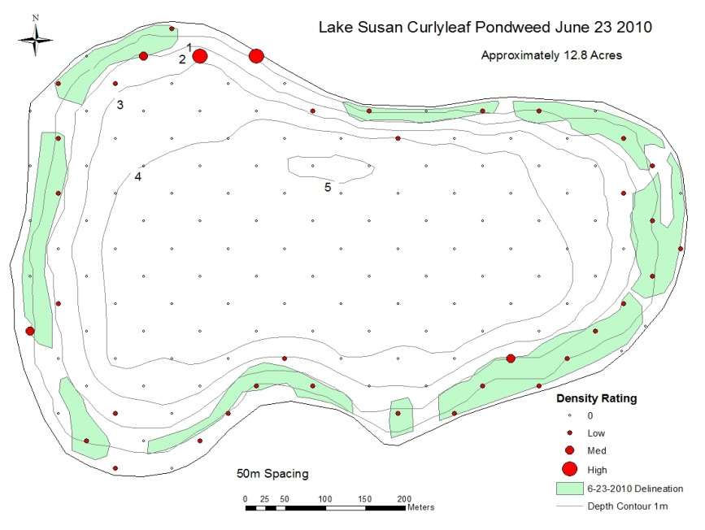

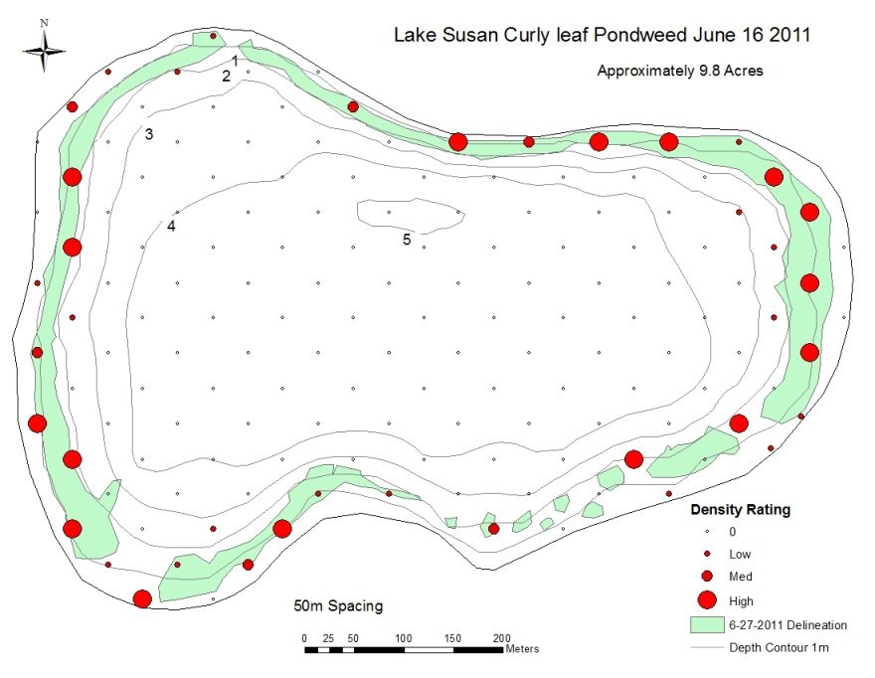
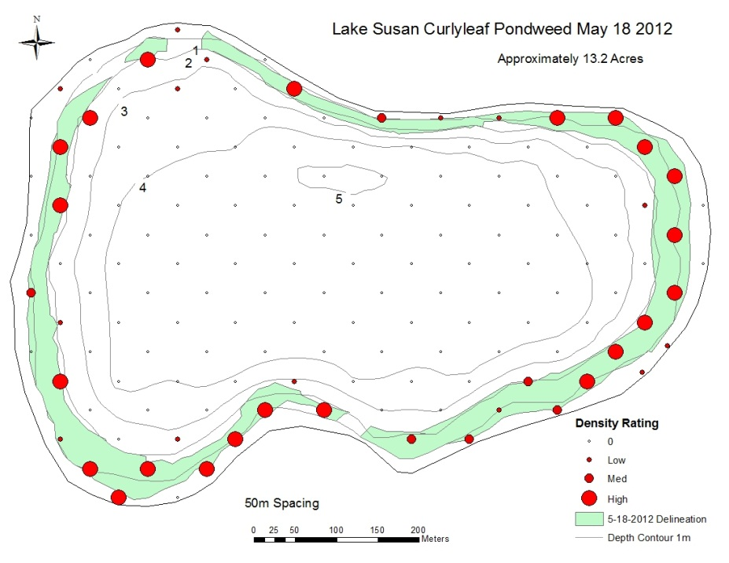

Appendix 3. Water clarity (Secchi Depth) in Lake Susan. Early season (before mid-July) clarity improved greatly after carp removal in 2009 but clarity still declines in July and August.

Appendix 4. Turion surveys were conducted in the fall of 2010, 2011, and 2012. Turions were collected using a petite ponar at 40 randomly chosen points from within the 122 points of the lake-wide point-intercept survey and the results are listed below. Ten additional points were sampled based on areas of particularly high densities of matted curly-leaf observed during peak growth in the spring.

Lake-wide littoral zone turion density and viability in fall of 2010-2012. Viability is the percentage of all turions collected that sprouted.

Year | Lake-wide mean per m² | Viability (%)
2010 | 24 | 90
2011 | 51 | 98
2012 | 87 | 98

Density and viability of turions collected from high-density curly-leaf areas in fall of 2010-2012.

Year | Lake-wide mean per m² | Viability (%)
2010 | 148 | 99
2011 | 220 | 88
2012 | 375 | 89

